Measurement Uncertainty for Pitch and Runout Artifacts

Bruce Cox, Oak Ridge Metrology Center at Lockheed Martin Energy Systems, Inc

Abstract

Primary-level calibration of pitch and runout artifacts require quantifying the measurement uncertainty on the artifact being calibrated by a method that does not rely on a transfer comparison. The measurement decomposition method, developed jointly by National Institute of Standards and Technology (NIST) and Oak Ridge Metrology Center (ORMC) personnel, is used to determine the uncertainty of each component of the measurement task. Once quantified, these components are added in quadrature according to NIST Technical Note 1297, 1994 Edition1. Verification of this method was accomplished by inter-comparisons between ORMC and NIST using high precision coordinate measuring machines and rotary tables. The results were also compared with data obtained using the circle closure principle.

Index and Runout Artifact Measurement Decomposition

In the case of an index and runout artifact, the uncertainty determination consists of checking pitch error using a rotary table and a 1440 Divider by the closure method; checking radial runout of the rotary table; and checking repeatability using an index artifact.

The pitch test which involved repeated measurements on three balls mounted so that a line through the first and second ball centers and a line through the first and third ball centers formed a 15° angle. In the pitch test, the balls were mounted on a1440 divider, which was also mounted on the rotary table, see Figure 1. When the divider was rotated 15°, the rotary table was rotated 15° in the opposite direction. The angle positions were analyzed by using the circle closure method, where all angles must add to 360°. The angle results are summarized in Table 1.

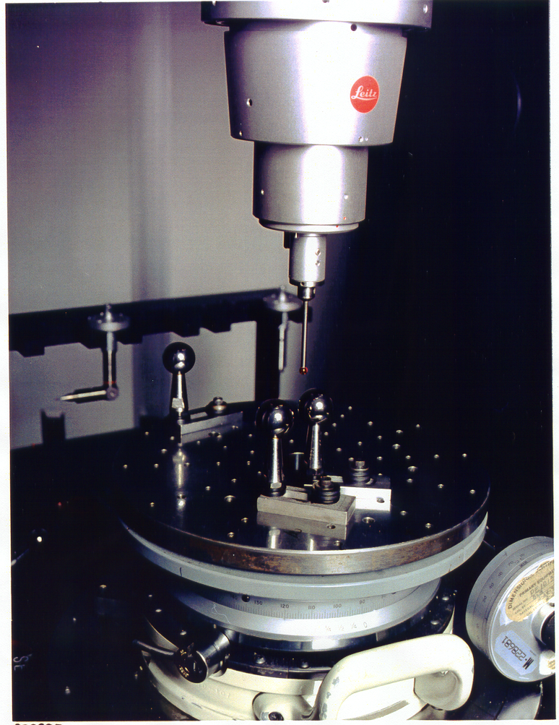
Figure 1 Checking rotary table error using 3 balls and 1440 divider by circle closure

Table 1. Pitch test with 3 balls using closure (arcseconds)
Nom. ang. | Run 1 | Run 2 | Run 3 | Run 4 | Run 5 | Run 6 | Run 7 | Run 8 | Run 9 | Run 10 | Run 11 | Run 12 | Run 13
0 | 0.00000 | 0.00000 | 0.00000 | 0.00000 | 0.00000 | 0.00000 | 0.00000 | 0.00000 | 0.00000 | 0.00000 | 0.00000 | 0.00000 | 0.00000
15 | 0.18000 | 0.21600 | 0.18000 | 0.25200 | 0.21600 | 0.25200 | 0.25200 | 0.18000 | 0.14400 | 0.25200 | 0.14400 | 0.28800 | 0.43200
30 | 0.36000 | 0.32400 | 0.25200 | 0.28800 | 0.36000 | 0.28800 | 0.28800 | 0.28800 | 0.18000 | 0.28800 | 0.18000 | 0.36000 | 0.32400
45 | 0.43200 | 0.43200 | 0.14400 | 0.28800 | 0.25200 | 0.21600 | 0.21600 | 0.18000 | 0.10800 | 0.28800 | 0.18000 | 0.43200 | 0.21600
60 | 0.18000 | 0.28800 | -0.21600 | -0.07200 | -0.14400 | -0.14400 | -0.14400 | -0.21600 | -0.25200 | -0.03600 | -0.07200 | 0.14400 | -0.07200
75 | 0.07200 | 0.10800 | -0.36000 | -0.25200 | -0.36000 | -0.36000 | -0.32400 | -0.36000 | -0.43200 | -0.25200 | -0.21600 | 0.03600 | -0.39600
90 | -0.03600 | 0.03600 | -0.32400 | -0.25200 | -0.43200 | -0.43200 | -0.39600 | -0.39600 | -0.46800 | -0.36000 | -0.25200 | -0.07200 | -0.46800
105 | -0.03600 | 0.07200 | -0.32400 | -0.21600 | -0.36000 | -0.36000 | -0.36000 | -0.39600 | -0.39600 | -0.36000 | -0.32400 | 0.00000 | -0.54000
120 | -0.10800 | 0.03600 | -0.39600 | -0.21600 | -0.39600 | -0.39600 | -0.46800 | -0.43200 | -0.50400 | -0.28800 | -0.43200 | -0.10800 | -0.68400
135 | 0.07200 | 0.18000 | -0.21600 | -0.10800 | -0.25200 | -0.28800 | -0.32400 | -0.28800 | -0.39600 | -0.21600 | -0.25200 | 0.00000 | -0.46800
150 | 0.03600 | 0.10800 | -0.32400 | -0.21600 | -0.36000 | -0.36000 | -0.43200 | -0.39600 | -0.46800 | -0.39600 | -0.32400 | 0.00000 | -0.28800
165 | -0.03600 | 0.18000 | -0.39600 | -0.25200 | -0.46800 | -0.39600 | -0.54000 | -0.54000 | -0.54000 | -0.50400 | -0.36000 | -0.07200 | -0.21600
180 | -0.14400 | 0.18000 | -0.68400 | -0.50400 | -0.72000 | -0.61200 | -0.72000 | -0.72000 | -0.68400 | -0.68400 | -0.50400 | -0.25200 | -0.32400
195 | -0.21600 | 0.07200 | -0.79200 | -0.54000 | -0.75600 | -0.72000 | -0.82800 | -0.79200 | -0.82800 | -0.79200 | -0.46800 | -0.36000 | -0.43200
210 | -0.28800 | -0.03600 | -0.86400 | -0.64800 | -0.82800 | -0.82800 | -0.90000 | -0.90000 | -0.86400 | -0.90000 | -0.57600 | -0.43200 | -0.54000
225 | -0.39600 | -0.14400 | -0.97200 | -0.57600 | -0.90000 | -0.86400 | -0.93600 | -0.97200 | -0.82800 | -0.90000 | -0.61200 | -0.46800 | -0.54000
240 | -0.39600 | -0.07200 | -0.90000 | -0.57600 | -0.72000 | -0.82800 | -0.90000 | -0.86400 | -0.75600 | -0.90000 | -0.57600 | -0.39600 | -0.61200
255 | -0.32400 | -0.07200 | -0.86400 | -0.54000 | -0.72000 | -0.72000 | -0.86400 | -0.79200 | -0.75600 | -0.82800 | -0.57600 | -0.43200 | -0.68400
270 | -0.32400 | 0.00000 | -0.79200 | -0.46800 | -0.61200 | -0.54000 | -0.72000 | -0.68400 | -0.72000 | -0.75600 | -0.57600 | -0.43200 | -0.57600
285 | -0.28800 | 0.00000 | -0.61200 | -0.46800 | -0.43200 | -0.50400 | -0.61200 | -0.61200 | -0.57600 | -0.64800 | -0.39600 | -0.36000 | -0.50400
300 | -0.39600 | -0.10800 | -0.68400 | -0.57600 | -0.50400 | -0.54000 | -0.64800 | -0.64800 | -0.61200 | -0.68400 | -0.46800 | -0.43200 | -0.57600
315 | -0.28800 | -0.03600 | -0.50400 | -0.43200 | -0.39600 | -0.43200 | -0.50400 | -0.43200 | -0.46800 | -0.54000 | -0.39600 | -0.32400 | -0.36000
330 | -0.14400 | -0.03600 | -0.25200 | -0.25200 | -0.21600 | -0.18000 | -0.28800 | -0.21600 | -0.21600 | -0.32400 | -0.25200 | -0.21600 | -0.18000
345 | 0.00000 | 0.03600 | -0.10800 | -0.07200 | -0.07200 | -0.03600 | -0.10800 | -0.10800 | -0.07200 | -0.10800 | -0.18000 | -0.14400 | -0.03600
360 | 0.00000 | 0.00000 | 0.00000 | 0.00000 | 0.00000 | 0.00000 | 0.00000 | 0.00000 | 0.00000 | 0.00000 | 0.00000 | 0.00000 | 0.00000

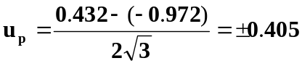The results of 13 runs of the pitch test, in arcseconds, were a maximum deviation of 0.432 a minimum deviation of -0.972. Using a rectangular distribution the standard deviation is calculated below (in arcseconds):

Next, a test was conducted, which involved a known ball mounted in the center of the rotary table at two heights to determine the radial runout of the table. A ball was mounted on the centerline of the rotary table and the radial runout was measured at two heights above the table,
9 7/8" and 2 1/2", see Figure 2. The results are shown below in Table 2:

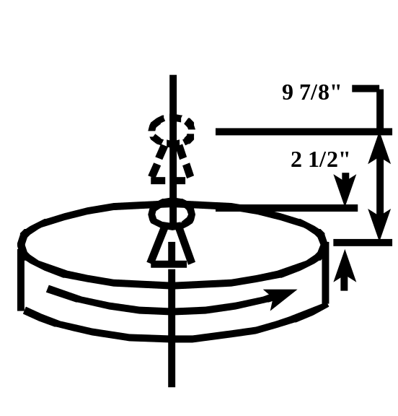
Figure 2 Radial runout test
Table 2. Radial Runout Test (mm)
Number | Radial Runout High  9 7/8" | Radial Runout Low  2 ½"
1 | 0.00028 | 0.00018
2 | 0.00031 | 0.00014
3 | 0.00032 | 0.00016
4 | 0.00028 | 0.00018
5 | 0.0003 | 0.00017
6 | 0.00031 | 0.00022
7 | 0.00031 | 0.00015
8 | 0.00031 | 0.00019
9 | 0.00029 | 0.00015
10 | 0.00034 | 0.00014
11 | 0.00032 | 0.00021
12 | 0.00031 | 0.00015

The maximum deviation of the radial runout test at two heights was 0.000340 mm. Taking the arctan of the maximum deviation times sin 20° divided by the base radius of 57.15 mm (simulating a 4.5" base circle diameter) and multiplying by 3600 to convert to arcseconds gives a total range of ±0.420 arcseconds (see Figure 3).

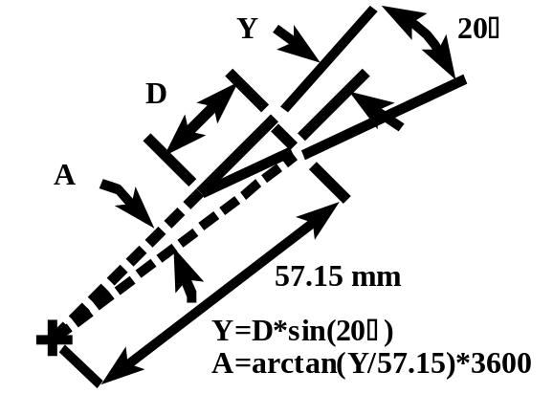

Figure 3 Calculation of angle error due to radial runout

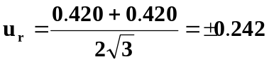The corresponding uncertainty is (in arcseconds):

The index artifact from R. E. Smith, Inc. was used to measure repeatability, see Figure 4. The NIST part program was used with two modifications. Instead of one point being taken at the pitch diameter, five points were taken at the same location and the average of all points was used. The coordinate system was re-established on the first tooth at every 45° around the rotary table. One run constitutes eight measurements of each tooth (at every 45° position). The average of all eight measurements on each tooth is the value for each run. The results below in Tables 3 and 4 show the runs, the average of all runs, and the standard deviation of all runs:
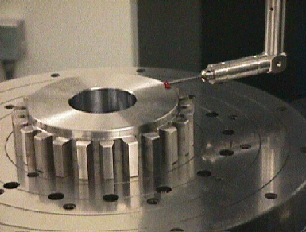

Figure 4 R. E. Smith index artifact

Table 3. Index Repeatability Runs (Right Flank)
Smith gear new 1 pt method
DATE: | 12/15/98 | 12/18/98 | 12/22/98 | 12/22/98 | 12/23/98 | 12/28/98 | 12/29/98 | AVG | STD DEV
TOOTH # | Micrometers | Micrometers | Micrometers | Micrometers | Micrometers | Micrometers | Micrometers | Micrometers | Micrometers
1 | 0.000 | 0.000 | 0.000 | 0.000 | 0.000 | 0.000 | 0.000 | 0.000 | 0.000
2 | 1.573 | 1.579 | 1.863 | 1.762 | 1.569 | 1.595 | 1.498 | 1.634 | 0.129
3 | -0.059 | -0.093 | 0.048 | 0.068 | -0.083 | -0.167 | -0.114 | -0.057 | 0.086
4 | 0.985 | 1.042 | 1.255 | 1.240 | 1.010 | 1.051 | 1.022 | 1.086 | 0.112
5 | 1.100 | 1.191 | 1.483 | 1.369 | 1.225 | 1.229 | 1.187 | 1.255 | 0.129
6 | 1.016 | 0.968 | 1.367 | 1.251 | 1.040 | 1.107 | 1.055 | 1.115 | 0.143
7 | -0.231 | -0.112 | 0.086 | 0.094 | 0.025 | -0.062 | -0.150 | -0.050 | 0.123
8 | 0.357 | 0.491 | 0.860 | 0.670 | 0.662 | 0.570 | 0.512 | 0.589 | 0.161
9 | 0.235 | 0.449 | 0.789 | 0.652 | 0.540 | 0.510 | 0.458 | 0.519 | 0.173
10 | -0.456 | -0.311 | 0.024 | -0.111 | -0.135 | -0.242 | -0.321 | -0.222 | 0.160
11 | -0.124 | 0.065 | 0.400 | 0.188 | 0.189 | 0.130 | 0.059 | 0.130 | 0.160
12 | 0.805 | 0.994 | 1.340 | 1.113 | 1.133 | 1.029 | 1.028 | 1.063 | 0.162
13 | 0.333 | 0.520 | 0.745 | 0.508 | 0.666 | 0.596 | 0.593 | 0.566 | 0.131
14 | 0.400 | 0.648 | 0.979 | 0.784 | 0.786 | 0.678 | 0.682 | 0.708 | 0.176
15 | 0.759 | 0.904 | 1.316 | 1.043 | 1.122 | 0.988 | 0.954 | 1.012 | 0.176
16 | 1.275 | 1.464 | 1.767 | 1.581 | 1.577 | 1.484 | 1.485 | 1.519 | 0.149
17 | 1.371 | 1.446 | 1.793 | 1.570 | 1.624 | 1.514 | 1.505 | 1.546 | 0.136
18 | 1.208 | 1.495 | 1.779 | 1.547 | 1.555 | 1.510 | 1.446 | 1.506 | 0.169
19 | 1.630 | 1.664 | 1.641 | 1.780 | 1.760 | 1.738 | 1.680 | 1.699 | 0.060
20 | 1.210 | 1.323 | 1.632 | 1.406 | 1.425 | 1.337 | 1.357 | 1.384 | 0.130
21 | 0.623 | 0.459 | 0.811 | 0.688 | 0.595 | 0.668 | 0.606 | 0.636 | 0.107
22 | 0.778 | 0.714 | 0.996 | 0.779 | 0.763 | 0.775 | 0.527 | 0.762 | 0.137
23 | 1.135 | 1.116 | 1.395 | 1.228 | 1.150 | 1.200 | 1.120 | 1.192 | 0.099
24 | 1.492 | 1.480 | 1.765 | 1.579 | 1.459 | 1.555 | 1.427 | 1.537 | 0.11

Table 4. Index Repeatability Runs (Left Flank)
Smith gear new 1 pt method
DATE: | 12/15/98 | 12/18/98 | 12/22/98 | 12/22/98 | 12/23/98 | 12/28/98 | 12/29/98 | AVG | STD DEV
TOOTH # | Micrometers | Micrometers | Micrometers | Micrometers | Micrometers | Micrometers | Micrometers | Micrometers | Micrometers
1 | 0.000 | 0.000 | 0.000 | 0.000 | 0.000 | 0.000 | 0.000 | 0.000 | 0.000
2 | 0.113 | 0.156 | 0.147 | 0.065 | 0.189 | 0.109 | 0.208 | 0.141 | 0.049
3 | -0.522 | -0.448 | -0.481 | -0.459 | -0.433 | -0.594 | -0.371 | -0.473 | 0.071
4 | 0.434 | 0.548 | 0.562 | 0.564 | 0.586 | 0.539 | 0.669 | 0.557 | 0.070
5 | -0.270 | -0.150 | -0.171 | -0.177 | -0.090 | -0.195 | -0.113 | -0.167 | 0.059
6 | 0.964 | 1.120 | 1.048 | 1.026 | 1.104 | 0.992 | 1.164 | 1.060 | 0.073
7 | 1.199 | 1.176 | 1.092 | 1.136 | 1.134 | 1.102 | 1.250 | 1.156 | 0.056
8 | 0.404 | 0.384 | 0.368 | 0.369 | 0.354 | 0.319 | 0.480 | 0.383 | 0.050
9 | 0.512 | 0.640 | 0.485 | 0.494 | 0.480 | 0.464 | 0.607 | 0.526 | 0.069
10 | 1.374 | 1.294 | 1.263 | 1.222 | 1.217 | 1.21 | 1.397 | 1.282 | 0.076
11 | 1.711 | 1.667 | 1.616 | 1.634 | 1.509 | 1.585 | 1.751 | 1.639 | 0.080
12 | 1.273 | 1.205 | 1.009 | 1.058 | 0.846 | 0.969 | 1.183 | 1.078 | 0.150
13 | 1.461 | 1.435 | 1.162 | 1.183 | 1.062 | 1.211 | 1.365 | 1.268 | 0.152
14 | 1.512 | 1.297 | 1.128 | 1.218 | 1.012 | 1.098 | 1.266 | 1.219 | 0.163
15 | 1.416 | 1.284 | 1.030 | 1.153 | 0.928 | 1.049 | 1.256 | 1.159 | 0.170
16 | 1.469 | 1.255 | 1.070 | 1.173 | 0.962 | 1.129 | 1.317 | 1.196 | 0.167
17 | 0.599 | 0.398 | 0.206 | 0.288 | 0.035 | 0.208 | 0.394 | 0.304 | 0.180
18 | 0.940 | 0.855 | 0.641 | 0.722 | 0.473 | 0.593 | 0.740 | 0.709 | 0.158
19 | 0.638 | 0.539 | 0.443 | 0.566 | 0.326 | 0.469 | 0.621 | 0.515 | 0.110
20 | 0.217 | 0.119 | -0.043 | 0.073 | -0.139 | -0.014 | 0.123 | 0.048 | 0.120
21 | -0.371 | -0.483 | -0.506 | -0.437 | -0.584 | -0.472 | -0.417 | -0.467 | 0.069
22 | -0.503 | -0.523 | -0.633 | -0.678 | -0.715 | -0.652 | -0.531 | -0.605 | 0.085
23 | -0.270 | -0.386 | -0.379 | -0.303 | -0.381 | -0.388 | -0.245 | -0.336 | 0.062
24 | -0.133 | -0.013 | -0.005 | 0.057 | -0.022 | -0.021 | 0.110 | -0.004 | 0.075

The maximum standard deviation for all runs was 0.180 micrometers. The maximum standard deviation in micrometers was converted to arcseconds by dividing by the deviation by the 1000* cosine (20°), then taking the arctanent of this product divided by the pitch radius of 78 mm and multiplying by 3600, see Figure 5.

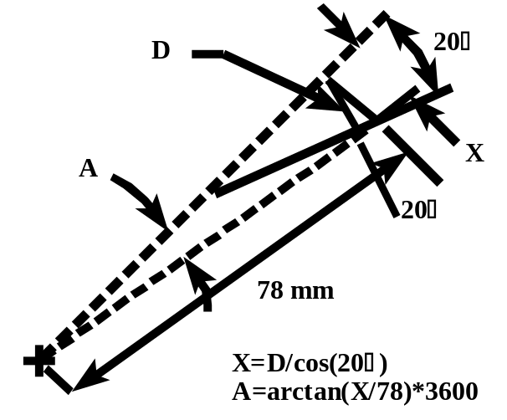
Figure 5 Calculation of angle error due to repeatability

The corresponding uncertainty is (in arcseconds):

u_{rp} = ±0.508

Index Measurement Uncertainty

The index measurement uncertainty standard deviation estimate (u_{i}) is thus (in arcseconds):

Multiplication of u_{i} by a factor (k) of 2 gives a total 95% confidence level uncertainty for index measurements

U_{i} = ±1.6 arcseconds

The uncertainty in deviation normal to the surface is expressed as:

U_{i} = ±R*tan(A/3600)*cos(PA)

Where: R - is the measurement radius
A - is the uncertainty in arcseconds
PA - is the pressure angle at the measurement radius of the index artifact

For example, the Bob Smith artifact uncertainty normal to the surface is:

U_{i} = ±78*tan (1.6/3600)*cos(20°)
U_{i} = ±0.57 micrometers
Inter-comparison Measurements

Inter-comparison measurements were made between CMMs at NIST and ORMC; and between a CMM at Gleason using the R. E. Smith artifact, see Figures 6-14. The inspection program between NIST and ORMC is nearly identical, while the inspection analysis application software on the Gleason CMM is completely different. The ORMC and Gleason runout data is from a physical ball check using a 7/16" diameter ball for the ORMC measurements and an 8 mm diameter ball for the Gleason measurements. R. E. Smith also input some of the index data from ORMC into his gear checking software to calculate runout. The R. E. Smith artifact has two alignment bands, one concentric to the gear teeth and one misaligned in order to show a large runout. All index inter-comparison measurements were within 3 micrometers and all runout inter-comparison measurements were within 10 micrometers. There seems to be some irregularities in the runout data from ORMC.
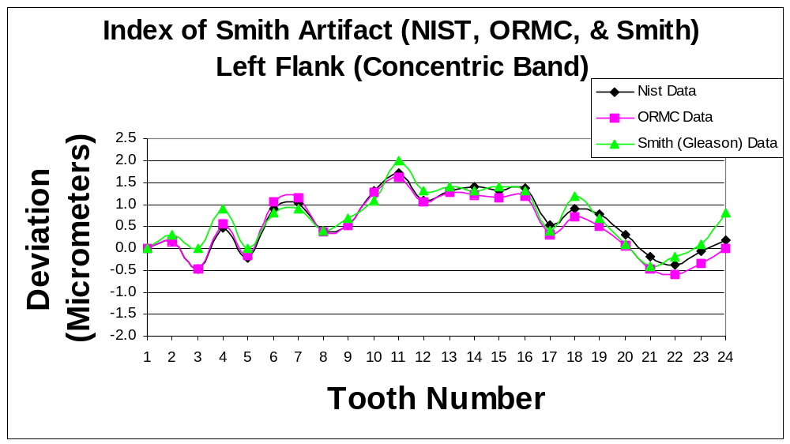
Figure 6 Index Inter-Comparison Data Between NIST, ORMC, and Smith (Gleason) For Concentric Band on Left Flank of R. E. Smith Aritfact

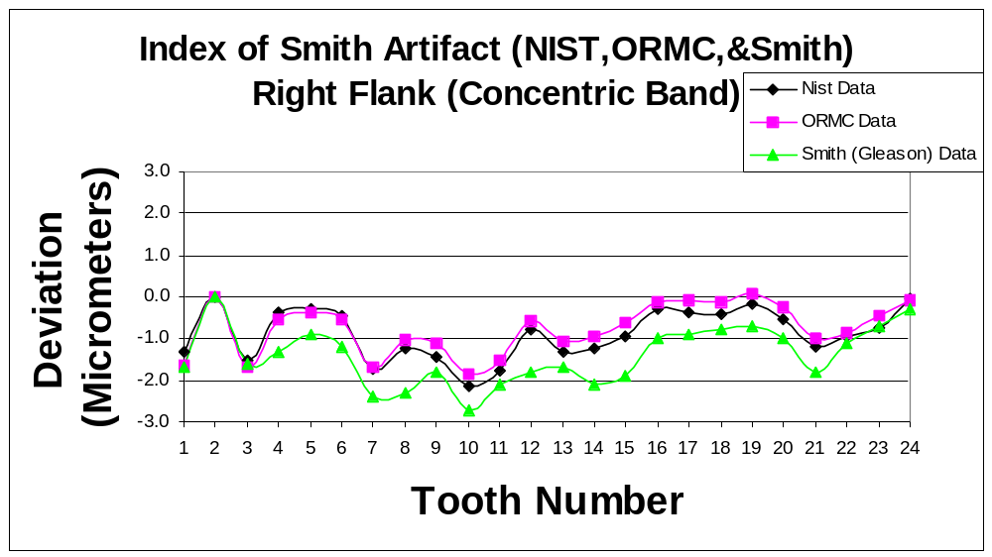
Figure 7 Index Inter-Comparison Data Between NIST, ORMC, and Smith (Gleason) For Concentric Band on Right Flank of R. E. Smith Aritfact

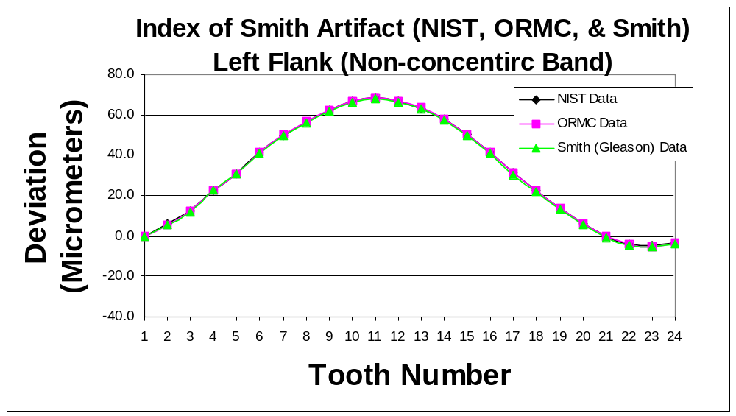
Figure 8 Index Inter-Comparison Data Between NIST, ORMC, and Smith (Gleason) For Non-Concentric Band on Left Flank of R. E. Smith Aritfact
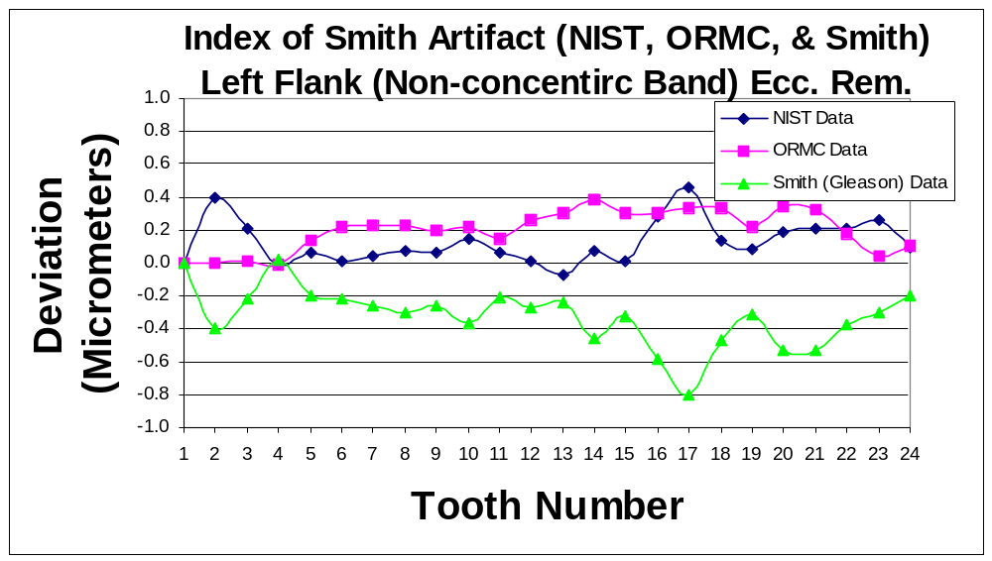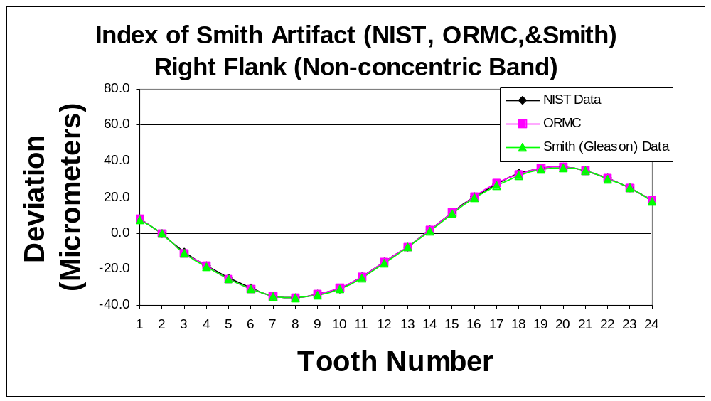
Figure 9 Index Inter-Comparison Data Between NIST, ORMC, and Smith (Gleason) For Non-Concentric Band on Right Flank of R. E. Smith Aritfact
Figure 10 Index Inter-Comparison Data Between NIST, ORMC, and Smith (Gleason) For Non-Concentric Band on Left Flank of R. E. Smith Aritfact with the Eccentricity Removed

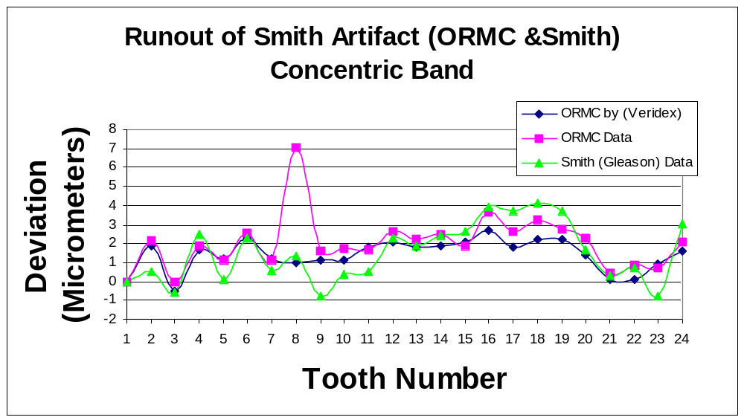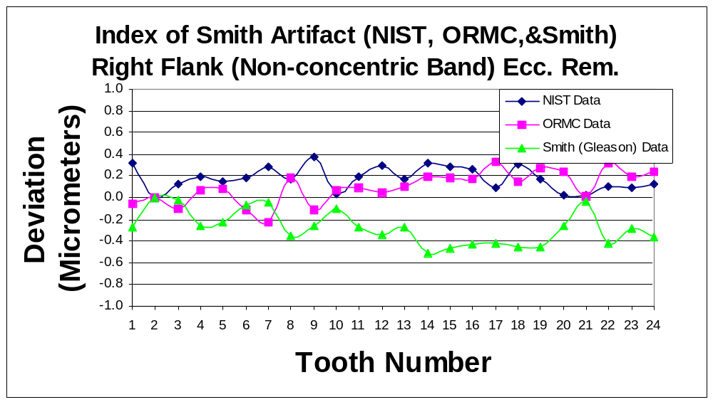
Figure 12 Runout Inter-Comparison Data Between ORMC, ORMC Calculated From Index, and Smith (Gleason) For Concentric Band of R. E. Smith Aritfact
Figure 11 Index Inter-Comparison Data Between NIST, ORMC, and Smith (Gleason) For Non-Concentric Band on Right Flank of R. E. Smith Aritfact with the Eccentricity Removed

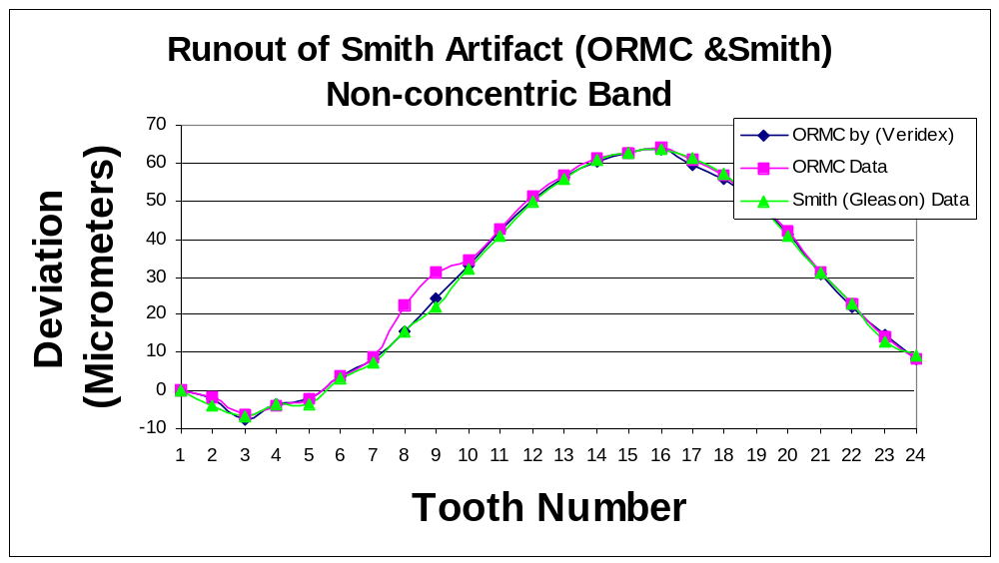
Figure 13 Runout Inter-Comparison Data Between ORMC, ORMC Calculated From Index, and Smith (Gleason) For Non-Concentric Band of R. E. Smith Aritfact

Figure 14 Runout Inter-Comparison Data Between ORMC, ORMC Calculated From Index, and Smith (Gleason) For Non-Concentric Band of R. E. Smith Aritfact with the Eccentricity Removed
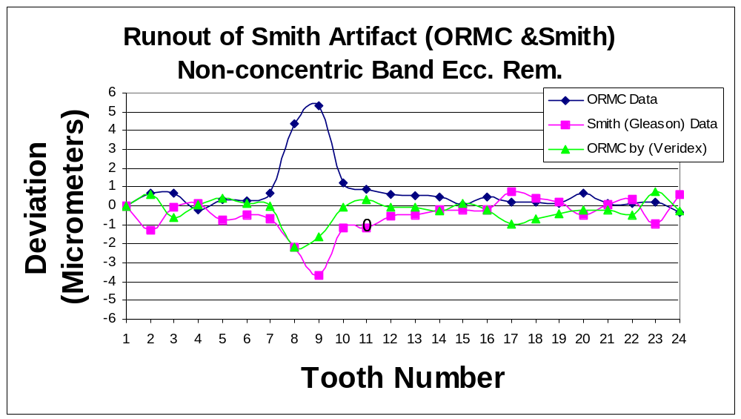
Conclusions
Figure 13 Runout Inter-Comparison Data Between ORMC, ORMC Calculated From Index, and Smith (Gleason) For Non-Concentric Band of R. E. Smith Aritfact

The established measurement uncertainty for index is ± 1.6 arcseconds or ± 0.6 micrometers for a 78 mm radius artifact. Runout can either be calculated from index data or measured with a ball in contact with both flanks of the index and runout artifact. Inter-comparisons between NIST and ORMC are within the above stated uncertainty, but inter-comparison measurements with a Zeiss CMM at Gleason is slightly outside the stated uncertainty. There also seems to be some measurement irregularities when measuring runout at ORMC. This is probably due to dirt or lint on the artifact. The R. E. Smith artifact is well designed to measure both index and runout with the concentric and non-concentric bands.

Acknowledgements

Thanks to R. E. Smith for providing the index and runout artifact for our inter-comparison and for providing runout calculations from our ORMC index data. I also wish to thank Dr. Howard Harary at the National Institute of Standards and Technology and Mark May at The Gleason Works for providing inter-comparison measurements on the R. E. Smith artifact.

References

- Guidelines for Evaluating and Expressing the Uncertainty of NIST Measurement Results, NIST Technical Note 1287, National Institute of Standards and Technology, Gaithersburg, MD., 1994.

